Лабораторная работа №13

Вариант 13

func(□)+ (begin;(□) * (abs()|□+ (x+ ));)* □ + end;

|  |  |  |  |  |  |
| --- | --- | --- | --- | --- | --- |
| func | □ | begin | abs | x | end |
| a | b | c | d | e | f |

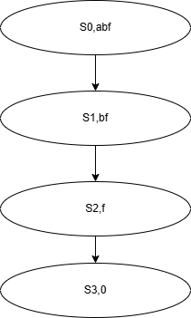Варианты цепочек:

abbf

abbcdbf

abbcbdbbcbebf

abbbbcbbbdbcbbbebebf

abcbdbcbbdbcbbbebebebf

abcbebcbdbebebf

abbbcbdbcbebebcbdbf

|  |  |  |  |  |  |  |  |  |
| --- | --- | --- | --- | --- | --- | --- | --- | --- |
|  | func | □ | begin | abs | x | ; | λ | end |
| S0 | S1 |  |  |  |  |  |  |  |
| S1 |  | S1,S2 |  |  |  |  |  |  |
| S2 |  |  | S3 |  |  |  | S8 |  |
| S3 |  |  |  |  |  | S4 |  |  |
| S4 |  | S4 |  |  |  |  | S5 |  |
| S5 |  | S5,S6 |  | S7 |  |  |  |  |
| S6 |  |  |  |  | S6,S7 |  |  |  |
| S7 |  |  |  |  |  | S2,S8 |  |  |
| S8 |  | S8,S9 |  |  |  |  |  |  |
| S9 |  |  |  |  |  |  |  | S10 |
| S10 |  |  |  |  |  | S11 |  |  |

func(□)+ (begin;(□) * (abs()|□+ (x+ ));)* □ + end;

